Table of contents

[Topic 1 / Structure and bonding 2](#_Toc23601)

[Topic 2 / Atomic structure & pTable 4](#_Toc4332)

[Topic 3 / Bonding and structure 7](#_Toc29558)

[Topic 4 - 5 / Organic Chemistry 9](#_Toc5396)

[Topic 6 / Enthalpy change 13](#_Toc2624)

[Topic 7 / Intermolecular forces 15](#_Toc27281)

[Topic 8 / Redox, Group 1.2.7, Tests & Expers 16](#_Toc29057)

[Topic 9 / Kinetics and Equilibria 20](#_Toc19078)

[Topic 10 / Organic chemistry: other sh- 22](#_Toc26172)

[References 25](#_Toc23731)

# Topic 1 / Structure and bonding

**Expected skills** - Writing chemical formulas, identifying atoms | molecules | ions | compound, ionic equations, empirical formula, molecular formula

Calculation with mol ratio: **Divide self multiple other**

**Relative atomic mass** **Ar** - the average weighted mass of the isotopes of an element ratio to 1/12 mass of C12

Not a whole number - a sample is a mixture of isotopes in different abundance

**Relative molecular mass** - the average weighted mass of a molecule

**Empirical formula** - the smallest whole# ratio of atoms of each element of compound

**Molecular formula**  - the actual number of atoms of each element of molecule

|  |  |  |
| --- | --- | --- |
| 1. Mass number   [Z] Atomic number (p) |  | n = A - Z  e- = Z  p+ = e  Mass number: n + p  Atomic number: p |

## Reaction of acids

|  |  |
| --- | --- |
| Hydrochloric acid - HCl  Nitric acid - HNO3 | Sulfuric acid - H2SO4  Phosphoric acid - H3PO4 |

Basicity n - Hydrogen’s base in an acid, mole ratio

Metal + acid → salt + hydrogen

Metal oxide + acid → salt + water

Alkali + acid → salt + water // alkali are hydroxides of metal HnA + nMOH → MnA + nH2O

Metal carbonate + acid → salt + water + carbon dioxide

## Displacement and precipitation reactions

**Displacement reactions:** (Mr1 > Mr2) ? (M1 displace M2 : no reaction)

**Precipitation reactions:** Double displacement reactions. Build equations with the solubility chart.

Ca(OH)2(aq) + CO2(g) → CaCO3(s) + H2O(l)

Calcium carbonate is a white precipitate, so Calcium hydroxide solution (limewater) turns milky

|  |  |
| --- | --- |
| **Metal** | **Flame test** |
| Li | Red |
| Na | Golden Yellow |
| K | Lilac |
| Ca | Brick-red |
| Mg | Bright white |
| Fe | Yellow sparks |

## Test for elements

S2- : Ba2+ → White precipitate

Halogens : AgNO3 → Silver halides (white / cream / yellow precipitate)

Pb2+ : I- → Yellow precipitate

Cl2(g): damp blue litmus paper → red

## Mole & stuff

### Conversion

1g = 1cm3

cm3 / 1e3 = dm3

cm3 / 1e6 = m3

C + 273 = K

25C | 298K + 101kPa

Moles

**Molar volume** - the volume of gas that contains one mole of that gas, @ r.t.p, Vm is usually 24  
Solid: // asked about: mol g Mr

Liquid: // asked about: mol dm-3 Molarity // same amount diff volume: Mv = Mv

|  |  |
| --- | --- |
| p | pressure (Pa) |
| V | volume (m3) |
| n | mol |
| R | 8.31 J K-1 mol -1 |
| T | temperature (K) |

Gas: // asked about: mol dm-3 molarVolume

Molar volume:

Ideal gas:

### Mole calculation reminders

mol of O = mol of CO2 • 2

If a reaction has compounds which consists of the same element, the mass of that element is:

### Molar volume & concentration

### Number of atoms

Number of atoms in a compound = Occurrence (e.g. S6 = 6 S atoms)

Number of compounds in a mol = mol \* 6.02e23

Number of atoms in compound in a mol = Occurrence \* mol \* 6.02e23

### Other stuff

**Atom economy** - the Mr of the desired product divided by Σ Mr of all product in %

# Topic 2 / Atomic structure & pTable

**Isotopes** - different atoms with the same number of protons, but different numbers of neutrons.

- diff atoms w/ same n of p diff n of n

**Relative isotopic mass** - the mass of an individual atom of a particular isotope

## Mass spectrometry

[[Link to topic 10]](#_Mass spectrometry of organic compounds)

1. Sample injected to mass spec → vaporised
2. Vapour bombarded w/ high energy e-.e- are removed from the atom → ionized to form +ive ions
3. **Electric field** → +ive ions to accelerate
4. +ive ions → deflected by the **magnetic field** (q2)
5. Deflected ions pass through narrow slit and are collected on a metallic plate connected to an amplifier
6. **Why do atoms have to be positively charged?**

For them to be accelerated and detected.

**Q. How mass spec distinguishes ions w/ diff. masses**

- Ions are accelerated by electric field and deflected by magnetic field

- Lighter ions are deflected more further

- Only ions with certain m/z ratio pass through the slit are detected

Detected mass/charge ratio = relative molecular mass

**If mass / charge ratio → molecular mass / x, the charge is x+**

**Molecular ion peak = molecular mass (highest m/z ratio)**

There is always a small % of the 13C isotope present in the compound → M+1 peak.

## IMG_256Atomic orbitals and electronic configurations

**Orbitals** - Region within an atom which an e- is likely to be found

**Quantum shell** - the energy level of an electron

**Hund’s rule** - e- will occupy orbitals singly before pairing takes place

*“Half-filled or completely filled d orbitals are more stable than those with 1 e- less”*

Cu: [Ar] 4s2 3d9 ← 3d has 1 e- less to full

Cu: [Ar] 3d10 4s1 ← this is the stablest configuration

### Shells and sub-shells

Orbitals: individual boxes

Sub-shells: orbitals with same character

Shells: orbitals with same number

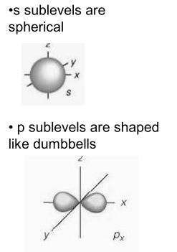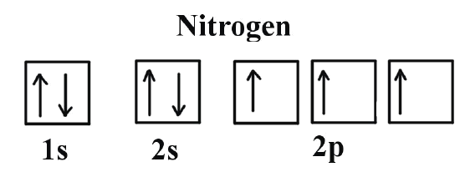

## Ionization energy

**First Ionization energy** - the amount of energy required to remove 1 mol of e- from gaseous atoms

**Equation** - An(g) → A(n+1)+(g) + e-

### C:\Users\enhan\Downloads\compress_30px.pngcompress_30pxFactors affecting IE

1. resize_vertical_30pxAttraction force from nucleus (↑protons↑attraction) **↑↑(pos relationship by definition)**
2. C:\Users\enhan\Downloads\rainbow_30px.pngrainbow_30pxDistance of e- to nucleus (bigger the atom, further outer e- are from the nucleus) **↑↓(neg)**
3. Shielding of the attraction from nucleus **↑↓**

### In an element...

**Same shell:** electron are being removed from an increasingly positive ion

**Change in shells:** electron is removed from a lower shell, which is closer to the nucleus

### 

### For elements...

**Q. Why do first IE decrease down a group?**

1 2 3

1. **Why is there a general increase in first IE across a period?**

1 2 3 // although 2+, the effect of that is overridden by 1, since they all belong in the same shell, 3 remains constant

**Q. Why has helium the largest first IE?**

1 2 3 // He has more e- than H, more p+, closest to n, no shielding

**Q. Why has Na has much lower first IE than Neon (pd1 → pd2)?**

1 2 3 // Effect of 2 and 3 overrides 1, since there are only one additional proton

**Q. Why is there a small drop from Mg to Al (s → p)?**

- State e- configs before answering

- e- in 3p sub-shell easier to remove because 3p e- are higher in energy

- 3p orbital partially shielded by 3s e-

**Q. Why is there a small drop from P to S (p3 → p4)?**

- State e- configs before answering

- e- are being removed from orbital containing 2 e- (paired)

- e--e-  repulsion between the paired e-

To explain selection from different choices, state periodic trends of IE or difference in shells

### Deducing electronic structure from successive ionisation energies

**How to deduce electronic arrangement?**

1. State electronic arrangement (1s22s22p63s1)
2. Jumps of IE indicate the change in shells
3. State jumps of IE

**What can be deduced?**

1. The number of shells
2. Electronic arrangement (2,8,1)
3. The number of electrons in each shell

## Reaction types

First ionisation energy - **Endothermic** reaction, since it requires an energy input

First electron affinity - **Exothermic** reaction, energy is released when this happens

## Periodicity

The trends in periodic table which are repeated across periods / groups.

### Atomic radius

**Trend** -↓across period

**THIS TREND CURVES**

num of p, nuclear charge **↑↑**

Distance of e- to nucleus **↑↓**

### Melting points

Determined by the strength of the bonds holding that substance together, ↑energy is required to break the bonds ↑m.p.

// use the ‘energy’ logic for a point in 3-pt questions

// also state the structure, and explain the intermolecular forces!

**Comparing metals** - Charges of ions, number of delocalised e-

**Giant covalent** - Giant covalent structure, strong bonding holding atoms together

**Comparing atoms** - Size of molecules, strength ofattraction between molecules, Van deer Waals forces for simple molecular,

# Topic 3 / Bonding and structure

Isoelectronic - Same number of e-

i-bond - attraction between oppositely charged ions

c-bond - shared pair of e-

da-bond - element donate pair of e- to share with element

EN - power of an atom to attract e- in a c-bond

p-power - the ability of cations to attract e- from anion

## Ionic bond Opposite charged ions

Ionic radius ↓ → Electrostatic attraction ↑ → Strength ↑M.p. ↑

number of p ↑ effective nuclear charge ↑→ Ionic radius ↓

Evidence of existence of ions: electrolysis w/ NaCl

Sodium @ -ve electrode, Chlorine @ +ve electrode

Cation causes polarization: Size ↓Charge↓ → **Polarizing power ↑**

Anions are polarized: Size ↑Charge↑ → **Polarizability ↑***(charge magnitude → more negative)*

## Covalent bond Shared pair of e-s and nuclei

**Type of bonds**

End on overlap: σ bond // sigma

Sideways overlap of 2 p-orbitals: π bond

* σ bond forms before π bond
* σ bond stronger than π bond // these contribute to the **Bond strength**

Size ↓Bond length ↓Bond strength ↑

Graphite lubricating properties are as a result of adsorbed gases on the surface of the carbon atom

Electronegativity - power of an atom to attract e- in a c-bond - Same trend **& dependencies** with IE ⬈

**Electron deficient**: Atom with a higher EN δ-, lower EN δ+ //negative attracts positive

EN difference ↑Polarity ↑

**Octet rules exceptions: Be4 B6 P10 S12 Cl I**

## Metallic bond Delocalised e- and cations

Lattice surrounded by sea of delocalised e-, they travel thru solid when potential is applied conduct electricity

Thermal conductivity: Ek of delocalised e- / closely packed cations → transfer of energy

Malleable: The layers of cation slide over one another

### Metallic bonding strength (m.p.)

- number of de- ↑

- **ions** has higher charge density: size ↓ charge ↑

- This leads to greater attraction between de- and **ions**

## Deducing structure

low mp + (g, l) -> simple molecular

conduct electricity (s) -> giant metallic

conduct electricity (m, aq) -> giant ionic (s)

high mp -> giant covalent (s)

|  |  |
| --- | --- |
| Shapes of molecules & ions **Electron pair repulsion theory**   1. L > L-B > B-B pair repulsion   **Deducing bond angles**   1. State bonding pair 2. Repels equally 3. As far as possible 4. To form the molecule shape   Symmetrical → dipoles cancel each other → non-polar  Non-symmetrical → dipole reinforce each other → polar  Element more electronegative → polar bond | Physical properties **Melting Boiling points**  Determined by the strength of attraction between atoms  **Conductivity**  **Determined by structure & state of compound**  Determined by amount of delocalised e-  Determined by how fluid the delocalised e- is:  → Bigger metal size would have looser outermost e-  **Solubility in water**  Determined by if the substance is polar |

## Molecule shapes

|  |  |  |  |  |  |  |
| --- | --- | --- | --- | --- | --- | --- |
|  |  |  |  |  |  |  |
| 2 0  linear | 3 0  trigonal planar | 4 0  tetrahedral | 5 0  trigonal bipyramidal | 6 0  octahedral | 3 1  trigonal pyramidal | 2 2  v-shape |
| 180° | 120° | 109.5° | 90° 120° | 90° 180° | 107° (NH3 109.5º) | 104.5° |

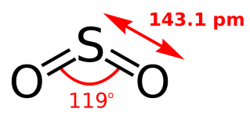Molecules like SO2 have bond angle of 120º because of the repulsion of the double bond and the lone pair.

## Bonding physical properties

|  |  |  |  |  |
| --- | --- | --- | --- | --- |
|  | **Giant metallic** | **Giant ionic** | **Simple molecular** | **Giant covalent** |
| Examples | Na Cu Zn Al | NaCl | H2 F2 I2 H2O NH3 CCl4 | C (Diamond, graphite)  SiO2 (Silicon dioxide, quartz) |
| Structure | WhatsApp Image 2021-08-18 at 4.33.59 PMSodium | WhatsApp Image 2021-08-18 at 4.33.59 PM  Sodium chloride | WhatsApp Image 2021-08-18 at 4.33.59 PM  Iodine | WhatsApp Image 2021-08-18 at 4.33.59 PM  Diamond |
| Bonds | Strong metallic bonds | Strong ionic bonds | Strong covalent bonds between atoms  Weak intermolecular forces between molecules | Strong covalent bonds |
| State @ r.t.p | Solids except mercury | Solids | Gas or liquids | Solid |
| m.b.p | ▲ | ▲ | ▼ | ▲ |
| hardness | ▲ | ▲ | ▼ | ▲ |
| Water soluble? | no | yes | no | no |
| Non-aqueous solvent soluble? | no | no | yes | no |
| Electrical conductivity | Good conductors  (delocalized e-) | Conducts electricity when melted or dissolved in water | No | No except graphite |

# Topic 4 - 5 / Organic Chemistry

[[Link to topic 10]](#_Topic 10 / Organic chemistry: other sh-)

Saturated - Compound with **C-C** only

Unsaturated - Compound with 1 or more **C=C**

Displayed formula - With bonds

Skeletal formula - carbon skeleton only

Structural formula - carbon by carbon

**Name Structural General Prefix**

Alk-ane - CnH2n+2

Cyclo-alk-ane - CnH2n

Alk-ene - CnH2n

Halogeno-alkane - CnH2n+1X

Alcoh-ol - CnH2n+1OH CnH2n+2O

Aldehydes - CnH2n+1CHO CnH2nO - al

Alkanoic acid - CnH2n+1COOH CnH2nO2 - oic acid

Ketone - CH3COCnH2n+1 CnH2nO - one [[more on this]](#_Oxidation of 1° alcohols - Aldehydes → Carboxylic acids)

Esters - oate

Functional group - group of atoms that is responsible for its chemical Rx

### 

### Naming

Find the longest mother chain

Side chains → prefixes in alphabetical order + index of C attached to

More than one identical side-chain → use multi-prefixes (di/ tri)

**Homologous series** - Groups of compounds with:

1. Same general formula that
2. Differ by CH2
3. Same functional group

## Isomerism

### Structural same molecular formula, diff structural formulas

Chain - diff arrangements of the carbon skeleton

Positional - side chains are attached to diff index of C

Functional group - same atoms arranged in diff functional groups

### Stereoisomers same structural formula, diff arrangement in space

There is **no rotation around C=C** bond

Geometric isomerism arise - **Each** end of C=C bond has 2 diff groups

No geometric isomerism - One end of C=C bond has 2 identical atoms

E trans - **priority group** opposite side | Z cis - same side

Side chain with higher atomic number is given priority for EZ naming.

*- Each C=C bond creates 2 isomers.*

## Reactions and mechanisms

Free radical - particle with an unpaired electron

→ Unpaired electron makes radicals very reactive

Homolytic fission - breaking of c-bond, each bonding e- leaves with each atom

Heterolytic fission - breaking of c-bond, both bonding e- taken by one atom

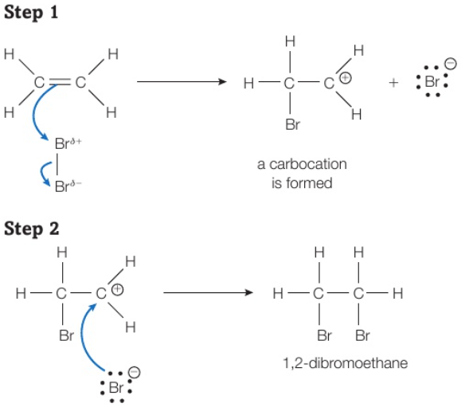Nucleophile - species with pair of e- which it donates to form c-bond (ions- / molecules with a δ- atom)

Electrophile - molecule which can accept pair of e-**s**

Addition - 2 reactant → 1 product

Substitution - 2 reactant → 2 product (usually molecules & ions)

Oxidation - Gain O2 & n & Lose H / e-

Reduction - Lose O2 & n & Gain H / e-

### Curly arrows

1. arrow starts at the bond / lone pair where e- are at start of reaction
2. the arrow points to where the new bond is formed

### Mechanism of addition reactions

Electrophilic reaction - electrophile’s positive end attracted to molecule → attack

Electrophilic addition - addition def + attacking molecule is electrophile

The C=C bond polarize Br-Br bond, Br δ+ is an electrophile

**Symmetrical molecules:**

There’s only one possible product

Carboncation:

* Carbon of C=C
* Only 3 bonds
* The carbon which positive atom not attached to in **Step 1**
* 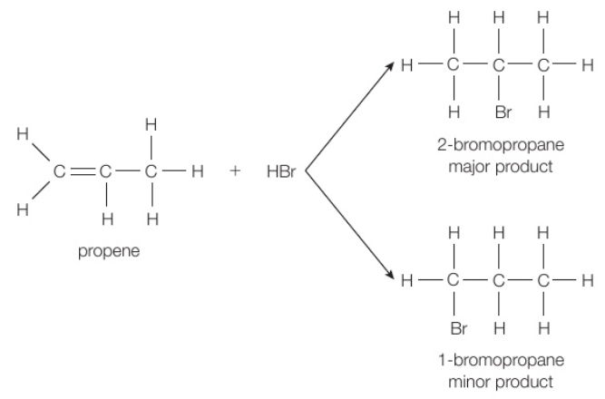In **Step 2** the negative atom is attached to it

**Asymmetrical molecules:**

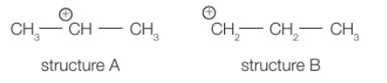A: 2 alkyl group joined to carboncation → Secondary carboncation

B: 1 alkyl group joined to carboncation → Primary carboncation

Charge of carboncation is spread over to more atoms, so A is more stable.

**Most EN element** attached to more stable carboncation → **Major**

**The stability of a carboncation** explains **major product yield**,

**NOT THE STABILITY OF THE PRODUCT**

### Mechanism of alkane substitution reactions

|  |  |
| --- | --- |
| **Question** | **Answer** |
| Why does a small amount of radicals cause large damage? | They participate in a chain reaction  The radicals are regenerate after each reaction  Many molecules decompose for each radical |

**Reaction steps**

1. Initiation - 1 molecule → 2 radical X2 ➔ 2X• (curly arrow)

2. Propagation - 1 molecule + 1 radical → diff molecule & radical (2 steps) X• + Y ➔ HX + Y• | Y• + X2 ➔ YX + X•

3. Termination - 2 radical → 1 molecule All Radicals• react with each other

**Further reactions**

H atoms can still be replaced by Halogens, forming other products:

E.g. CH3Cl + Cl2 → CH2Cl2 + HCl (Overall reaction)

|  |  |
| --- | --- |
| AlkenesHydrogenation → Alkanes Condition: **Pt / Ni**  C2H4 + H2 → C2H6 - Addition Halogenation → (Di)Haloalkanes This is an electrophilic addition reaction!  Rx with unsymmetrical alkenes will have mixture of products  C2H4 + X2 → C2H4X2 -Decolorised (Brown → Colorless)  C2H6 + HX → CH2XCH2CH3 - Minor product  C2H6 + HX → CH3CHXCH3 - Major product Producing alcohols Reagent: H2O(g) Condition: H2SO4 (catalyst)  CH2=CH2 + H2SO4 → CH3CH2OSO2OH  CH3CH2OSO2OH + H2O → C2CH5OH + H2SO4  Overall: C2H4 + H2O →[H2SO4]→ C2H5OH Oxidation with [O] → Diols [O] - H2SO4 / **acidified** KMnO4Potassium Manganate  C2H4 + [O] → CH2OHCH2OH - Decolorised (Purple → Colorless) Polymerisation | AlkanesHalogenation → Haloalkanes Condition: **UV light**  CH4 + X2 → CH3X + HX - Free radical substitution |

### Reaction rates

Alkenes react faster than alkanes since alkene has double pi bonds, while alkane has a sigma bond only. Pi bonds are weaker than sigma C-H bonds.

### Reaction map

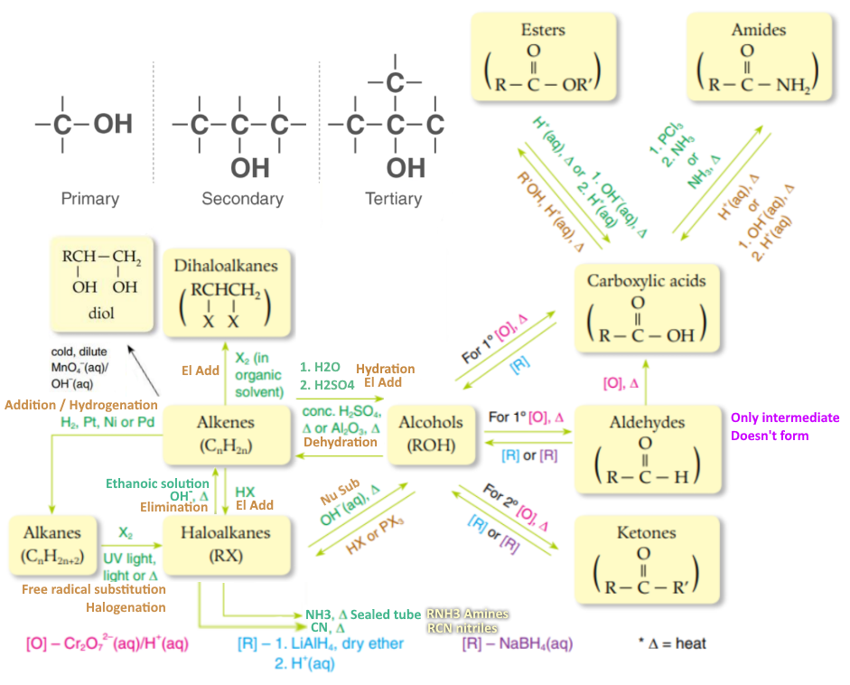

**Cr2O72-**

**Cr3+**

[[Halo Alcohol reactions]](#_Haloalkanes_1)

Alkanes as fuels

Crude oil - mixture of different hydrocarbons

### Fractional distillation

1. Crude oil vaporised

2. Fractionating column with temperature gradient - hotter bottom cooler top

3. Diff alkane have diff boiling points, condenses at a diff temperature

Don't condense - rise to top

Don't vaporize - run to bottom as residue

### Cracking larger alkane molecules are broken down into smaller molecules

Long alkane -> short alkane(s) + short alkene(s) (+ H2)

**Thermal cracking**

Produces a lot of alkenes

Higher temperature required @ 7MPa

**Catalytic cracking** - Zeolite catalyst

Produces Aromatic hydrocarbons (chemical compounds that contain one or more rings)

Lower temperature required @ 1 atm

- This method saves time (catalyst speeds up reaction) and money (less heat)

### Reforming turn straight -ane into branched & cyclic -ane / aromatic hydrocarbons

e.g. pentane -> cyclopentane + H2

## IMG_256Combustion of hydrocarbons

Complete CO2 + H2O

Incomplete No enough O2

> CO Poisonous

> C Soot

### Pollution of using alkane as fuel

Release CO2 green house gas → worsen greenhouse effect

→ trap heat inside earth → global warming

**Acid rain formation**

S + O2 -> SO2 / + O2 -> 2SO3

SO2 + H2O -> H2SO3 / SO3 + H2O -> H2SO4

---------------------------------------------------------------------------

N2 + O2 -> 2NO / + O2 -> 2NO2

2NO2 + H2O -> HNO2 + HNO3

|  |  |
| --- | --- |
| Alternative fuels **Advantage for biofuels:**   1. Renewable 2. Produce fewer CO2   **Disadvantage for biofuels:**   1. Land needed to grow 2. Uses food that can be eaten 3. Produces less energy per mass | Dealing with polymer waste **Reasons for increased use of polymers**  1. Manufactured on a large scale  2. Lighter in weight  3. Unreactive  **Biodegradable** - can be broken down by organisms  **Biodegradable polymer’s advantages**   1. Reduce waste in landfills 2. Reduce time for degradation 3. Reduce harm to wildlife |

**Catalytic converters** - remove pollutants: CO, C, NOx

# Topic 6 / Enthalpy change

Exothermic - ↓Temperature, gives off heat

Endothermic - ↑Temperature , heat is absorbed from surroundings

Hess’s Law - ΔH of a Rx is independent of the route

## Introduction

HΔ is for the reaction as *written*

Q = mcΔt *Q* heat energy | *m* mass of liquid, 1g = 1cm3 | *c* s.h.c. of water, if *m* in g, *c* = 4.18 J g-1 K -1

ΔH = *n* number of moles of reactants | Unit: kJ mol-1

When answering enthalpy change, answer MUST contain +/- signs

|  |  |
| --- | --- |
| **Question** | **Answer** |
| Enthalpy change of Rx can’t be measured directly | 1. If reversible reaction, endo can't be measured since hard to measure decrease temp when heating 2. Hard to measure temp of solid 3. Some substance might evaporate |
| The values obtained by experiments that are used in calculation are different than accurate | 1. Heat loss 2. Specific heat capacity is estimated |
| Accuracy of values | 1. Heat loss 2. Evaporation of reactants 3. Incomplete combustion |
| Why is something in excess? | To allow full *x* reaction of *compound* |
| Change of state explanation to energy | Change of state requires energy |

**The HΔ measured at 100kPa and 298K, (In standard condition, )**

Standard H Δ of Rx - eq quantities of materials react

Standard H Δ of Comb - 1 mol of substance is completely burned in O2 [Exo]

Standard H Δ of Neu - 1 mol of H2O produced by neutralisation [Exo]

Standard H Δ of Form - 1 mol of substance formed its element in standard states [Exo/Endo]

Standard H Δ of Atom - 1 mol of gaseous atoms is formed from ground state

Reaction - Rx

Combustion - X + O2 → CO2 + H2O

Neutralization - Acid + Alkali → Salt + H2O

Formation - Produces a single product created by all reactants

Atomisation - ½X2(ground) → X(g)

H Δ of solution - 1 mol of ionic compound dissolve in H2O to form solution of infinite dilution **[s→aq]**

H Δ of hydration - 1 mol of gaseous ion dissolve in H2O to form solution of infinite dilution **[i-g→aq]**

Lattice energy - ionic compound → gaseous ions **[s→g]**

Solution - NaCl(s) → Na+(aq) + Cl-(aq)

Hydration - Na+(g) → Na+(aq)

L.E. - NaCl(s) → Na+(g) + Cl-(g)

### Extra: Acid and bases

Acid - A substance which in an aqueous solution will release H+ ions

Base - A substance which reacts with an acid to form a salt and water only.

Alkali - A water-soluble base.

## Hess’s Law Cycle & Subtraction method

**Cycle: points are given as:**

1. Chemical formula
2. Arrow directions
3. Labeling arrows, both compound and ΔH

- Equation: arrows of the same direction on the same side,

**take account of mol ratio**

i.e. ΔHr + ΔH2 = ΔH1

**Subtraction method**

1. List out all formulas
2. Make sure elements are on the same side as the elements of the mother reaction
3. After switching equation directions, make sure to invert the +/- signs

Cancel out recurring elements, and sum up the ΔH values

## Bond enthalpy

|  |  |
| --- | --- |
| **Question** | **Answer** |
| Bond enthalpy calculations are inaccurate to given value | 1. Mean BH varies with environment 2. Mean BH does not include ΔH of the change of state |

Mean bond enthalpy - The ΔH when 1 mole of breaking of a bond in **gaseous** state, averaged out over diff molecules

Mean bond enthalpy values are inaccurate because they vary w/ environment, they do not equal to the actual bond enthalpy for specific elements

Breaking bonds is **always endothermic**, so mean ΔHb are always positive

### Formula

Diatomic modules - ΔBH: XY(g) → X(g) + Y(g)

Polyatomic molecules - ΔBH: XYx(g) → XY(x-1) (g) + Y(g) [repeated x times]

### Calculation

Expression of a bond’s mean bond H: E(X-Y)

ΔBH = Σ(bonds broken) - Σ(bonds made)

### Atomisation

Standard HΔ of atomisation- When **1 mole of gaseous atoms** is formed from **ground state**

ΔatH: X(s) → X(g)

ΔatH: (1/y)Xy(s) → X(g)

## Lattice energy

LE ↑Charge of ion ↑Distance between ions ↓

# Topic 7 / Intermolecular forces

|  |  |
| --- | --- |
| **Question** | **Answer** |
| Explain why ... has a greater BP than ... | 1. It has ... forces 2. Which is stronger than ... force   For same type of molecules, **MENTION WHAT FORCES** and which one of them is greater |

## Induced dipoles / London / vdw forces

* Exists between all types of molecules.
* Weak, but greater in number
* 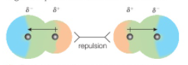Depends on the number of e- in the molecule

## Permanent dipoles

* When dipoles are aligned correctly, there will be attraction between the molecules
* 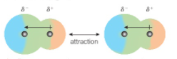Else, there will be repulsion
* On average, the attraction and repulsion cancels each other, resulting in a weaker force

## Hydrogen bond

* “Strongest intermolecular force”, unless there are a large number of e-
* The strength of the hydrogen bond depends on the **EN difference** of HX
* H bonds with a high EN atom, most commonly **F > O > N > S**
* H bonds with **a lone pair** of e-
* **Intramolecular H-bond: H must be bonded to the atom to form a H-bond**
* CH3F ✕ HF ✓

## Boiling points

### Hydro-carbons

The boiling points depends on the **number of points of contact**, **number of e-** and **h-bonds**. ~~Bond strength~~ no bonds broken

# of points of contact - Increases I-force, since molecules are more closely packed: so straight chain H-C have higher BPp

Number of e- - Increases l-force & pd-force

1. bonds - If the h-carbon is an **alcohol**, the h-bond significantly increases the BP

### Hydrogen Halides

All of the hydrogen halides have Permanent & Induced dipole forces, since they are all polar.

HF - H-bond > L-force given e-

HI - L-force > HBr

HBr - L-force > HCl

HCl - L-force

## IMG_256Water

**Density of ice < density of water** due to the structure by **h-bond**, which creates a lot of open space.

The H-Bond angle is **180º**

**Dissolving** - Water molecules pulls the δ+ and δ- ions apart, using the δ- and δ+ ends of the water molecules. H in H2O forms H-bond with the δ- ion.

### Solubility - Similar dissolves similar!

Compare the bond strengths between **H2O & compound** and **within H2O & compound**, if the strengths are similar → dissolve

Solubility is less if bond strength differences are greater

# Topic 8 / Redox, Group 1.2.7, Tests & Expers

## Redox reactions

**Oxidation** - e- #o - agents are Reduced to Oxidize other molecules agent def: substance that gains e-

**Reduction** - e- #o - agents are Oxidized to Reduce other molecules agent def: substance that loses e-

Hydration - Addition of H2O to a molecule or compound

|  |  |
| --- | --- |
| **Question** | **Answer** |
| Explain in terms of redox, what happens to ... | State changes in e- / #o + if element is reduced / oxidized |
| Why is Cl added to water? | To destroy bacteria |
| Why the toxicity of Cl doesn’t prevent adding to water? | Benefit outweighs the risk / Used in dilute, small amounts |
| Simplest extraction of metal | Displacement: M1 + M22+ → M2 + M12+  Explain: Use recycled iron, M1 more reactive, displace |

### Oxidation numbers

**Roman numerals** is an oxidation number for the element in front of it. Fe[ Iron(ii) sulfate ] = +2

1. Elements = 0, Elementsx = 0 He, Ar, O2, H2
2. Ion charge = #o #o: Na+ = +1
3. Neutral compound = 0 Fe2O3
4. O = -2, O[H2O2] = -1
5. H = +1, H[Metal Hydride] = -1 H[HF] = -1

**Disproportionation reaction** - an element **of the same compound** undergoes both oxidation and reduction

### Half-Equations

Ionic half equations show oxidation / reduction: Na → Na+ + e-

Combining half equations by **balancing the e- #** can product a **full equation** for a Redox Rx

### Reducing and oxidizing strength

Oxidizing agents gains e- → molecule + e- more easily → stronger oxidizing agent.

Reducing agents loses e- → molecule - e- more easily → stronger reducing agent.

Electronegativity trends top right, EN ↓down the group. Higher EN → Attracts e- more easily

## Acids & Base

Acid: HCl > HNO3 > H2SO4  // Acids are mentioned in unit 1

Base: NaOH > NH3

Alkali are hydroxides of metal!

### Strengths of alkali

A compound is more alkali if **there are more OH- ions** and **less H+ ions**

Solubility of alkali ↑ → OH- ions present in solution ↑→ Alkali is more alkaline

|  |  |
| --- | --- |
| Group 1 Li Na K Rb Cs Fr | Group 2 Be Mg Ca Sr Ba Ra |
| Only one e- must be **lost** to be stable, radius ↑, outermost shell distance to nucleus ↑, attractive force ↓, easier to **lose** e- | |
| Solubility of SO42- ▼ BaSO4 insoluble  Solubility of OH- ▲ Mg(OH)2 insoluble  **All NO3 soluble** | |
| Reactivity ▲ down the group  ∴ MBP ▼  4M + O2 → M2O  2M + Cl2 → 2MCl  M + H2O → MOH(aq) + H2(g) Oxides M2O(s) + H2O(l) → 2MOH(aq)  M2O + H2SO4 → M2SO4 + H2O | Reactivity ▲ down the group, reacts less than Group 1  ∴ MBP ▼  2M + O2 → 2MO  M + Cl2 → MCl2  Mg(s) + H2O(g) → MgO(s) + H2(g) - Steam only  M + H2O → M(OH)2(aq) + H2(g) Oxides MO(s) + H2O → M(OH)2(aq)  MO + H2SO4 → MSO4 + H2O |

## Thermal stability

Thermal stability - A term that indicates how stable a compound is when heated

Melt - Ions change from a giant lattice structure to free movement in liquid

Decomposition - Processes in which compounds break up into simpler parts

Thermal stability ↑down the group, decompose → Stability ↓

Charge density ↓Metal ion polarizing power ↓ C-O bond strength ↑ Thermal stability ↑

Group 2 **carbonates CO32-** and **nitrates NO3-** decompose due to greater i-bond strength

All G1&2 nitrates & carbonates are **white solids**.

### Heating group 1&2 carbonates

When carbonates are heated, they **decompose and gives off CO2 / don’t decompose**

**Decomposition occurs** when **cation 2+ charge / Li+**

MCO3 → MO + CO2

### Heating group 1&2 nitrates

When nitrates are heated, they **decompose** (which is a redox Rx), and it may give off NO2 which are **brown fumes**

**Greater decomposition** occurs when **cation 2+ charge / Li+ (Li is the first element in group 1)**

✓brown fumes 2M(NO3)2 → MO + 2NO2 + ½O2 - Greater decomposition

✓brown fumes 2LiNO3 → Li2O + 2NO2 + ½O2 - Greater decomposition

✕brown fumes MNO3 → MNO2 + ½O2  - Lesser decomposition

## Test for sulphate ions

Ba(NO3)2 or HCl is used to add to the solution → white pp forms

Ba(NO3)2 + Na2SO4(aq) → BaSO4(s) + 2NaNO3(aq)

### Test for nitrogen dioxide

Blue damp litmus paper → Red

|  |  |
| --- | --- |
| **Metal** | **Color of flame when burnt** |
| Li+ | Red |
| Na+ | Yellow / Orange |
| K+ | Lilac |
| Mg2+ | No color / bright white |
| Ca2+ | Brick red |
| Sr2+ | Crimson red |
| Ba2+ | Apple green |

## Flame tests

### Execution

1. Dropper some conc. HCl → solid & mix → the metal compound dissolves

* HCl + metal compounds → chloride, which is more volatile → give better results

1. Dip a clean metal wire (e.g. Pt or Nichrome) → mixture to obtain sample
2. Hold the loop in the clear blue part of a Bunsen flame

### Problems

1. Impurities, like Na may hide other colors
2. Flame colors are subjective

### Cause of colors

When an e- excites and **de-excites**, it releases energy. The energy’s λ is the light’s λ

If the λ is within the visible range 400 - 700nm, there is visible color of flame, else no

## Group 7

One e- must be **gained** to be stable, radius ↑, attractive force ↓, harder to **attract** e- to complete shell

Explaining MBP: More e- ➔ greater l-force

Reactivity ▼ down the group ∴ MBP ▲

### Redox in group 7

Cl2 + 2M+ → 2MCl // Cl represents all halogens

Cl2 + M2+ → MCl2

Halogen can partake in **displacement Rx**. Any Rx that occurs is indicated by color Δ. Cl2 + 2NaBr → 2NaCl + Br2

The color depends on the concentration, halogens in organic solvent > soluble in water, dissolve in organic solvent → observation

**Disproportionation reaction** - Same element partake both red & ox

Halogen reacting with water - Cl2 + H2O → HCl + HClO - Cl -1 in HCl, +1 in HClO

Halogen Rx w/ dilute cold alkali - Cl2 + 2NaOH → NaCl + NaClO + H2O - Cl -1, +1

Halogen Rx w/ conc. hot alkali - 3Cl2 + 6NaOH → 5NaCl + NaClO3 + 3H2O - Cl -1, +5

Down the group, halides are easier to lose e-, ↑reducing power

## Halides Rx w/ sulfuric acid

**All reactions except HX are redox reactions**.

### Observations

**Dilute nitric acid** HNO3 is added first to make sure that any other anions are removed to prevent forming pp

|  |  |  |
| --- | --- | --- |
| **Halide** | **Products** | **Observations** |
| NaCl | Misty fumes | HCl |
| NaBr | Misty fumes  Brown fumes  Colorless gas w/ choking smell | HBr  Br2  SO2 |
| NaI | Misty fumes  Purple fumes  Colorless gas w/ choking smell  Yellow solid  Colorless gas w/ rotten egg smell | HI  I2  SO2  S  H2S |

### Sulfuric acid half equations

Reduction of halide ions - 2X- → X2 + 2e- - 2I- → I2 + 2e-

Production of Hydrogen halides - H2SO4 → H+ + HSO4- - NaI + H2SO4 → HI + NaHSO4

## Halides Rx w/ other solutions

### Testing for halide ions in solution:

Silver nitrate is acidified to remove anions that would interfere with the test

|  |  |  |  |
| --- | --- | --- | --- |
| **Initial** | Chloride | Bromide | Iodide |
| **+ Silver nitrate AgNO3(aq)** | White pp | Cream pp | Yellow pp |
| **+ Dilute NH3(aq)** | Soluble → clear | Insoluble | Insoluble |
| **+ Conc. NH3(aq)** | Soluble → clear | Soluble → clear | Insoluble |

### Equations

Ag+(aq) + X- → AgX(s) - AgNO3+ NaX(aq) → AgX(s) + NaNO3

HX + H2O → H3O+ + X- - HF is a weak acid: HF + H2O ⇌H3O+ + X-

HX(g) + NH3(g)→ NH4X(s) - HCl(g) + NH3(g) → NH4Cl(s) Ammonium chloride

⬊NH4X is a white ionic solid (Salt)

## Practicals

Standard solution - A solution whose concentration is accurately know

### Titrations

|  |  |
| --- | --- |
| **Action** | **Reason** |
| Fill burette so that the space between tap & tip is full of solution | When the level goes down, the liquid will fill this space instead of going out |
| Stop adding solution when the indicator just changes color | Increase accuracy, adding more solution doesn’t change color |
| Rinse the conical flask with deionised water only | If used solution, there will be unknown extra amount of substance added to calculation, creating an error |
| Why is the first titre’s result greater? | 1. First titre might be a rough run 2. There was an air bubble in burette |

Phenolphthalein - **pink → colorless**

Methyl orange - **yellow → red**

## Mistakes & Errors

A skilled operator will find an error difficult to avoid, whereas a mistake is the opposite

Error - Difference between experimental & correct value

Accuracy - How close values are to the correct value

Precision - How close values are to each other

## Measurement errors & uncertainty

Random error - caused by unpredictable variations in conditions

Systematic error - constant / predictable, commonly due to apparatus used

Uncertainty - The potential error when measuring using an apparatus

### Calculating uncertainties

Percentage uncertainty

# Topic 9 / Kinetics and Equilibria

Activation energy - Min. energy that colliding particles must possess for a Rx to occur

|  |  |
| --- | --- |
| **Question** | **Answer** |
| Explain the effects on the rate of reaction of … | - **Molecules with at least the activation energy can react**  - Factor → Increase freq of collision → Δ rate of reaction |

### Collision theory

Two particles must

1. Collide in the **right direction**
2. 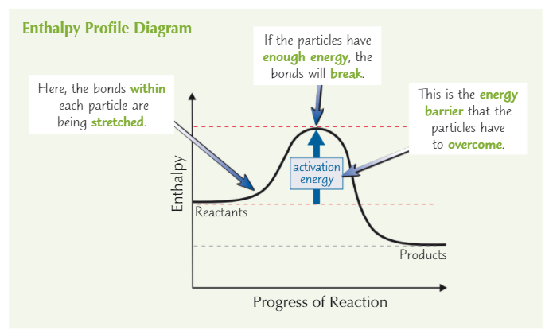Collide with at least the **activation energy**

to react

## Factors that increase the rate of reaction

The graph under the MBD curve doesn’t change because number of molecules remain constant

### Temperature

1. The particles will have energies higher than Ea **on average**
2. They’ll collide with higher frequency

### Concentration

1. The particles will be closer together
2. They’ll collide with higher frequency

There will be no change in the Maxwell-Boltzmann Distribution graph

### Pressure

This only affects gas, since changing the pressure has almost no effect on solids / liquids, their volume doesn’t change much

1. The particles will be closer together
2. They’ll collide with higher frequency

### Surface area

Heterogeneous Rx - the reactants are components of 2 or more phases - X(s) + Y(aq)

This affects **heterogeneous reactions w/ solid** only, since only collisions between atoms on the **surface** can result in a Rx.

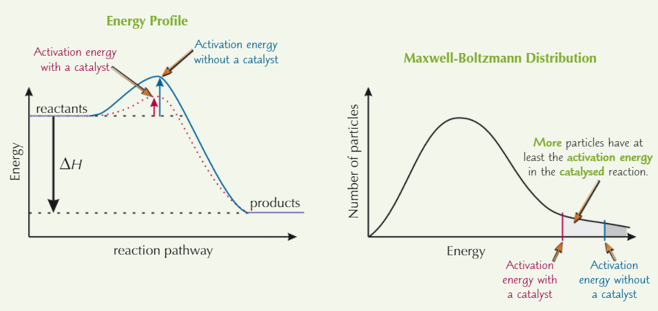└ If the solid is powdered, surface area ↑

### Catalysts

Catalysts - A substance ↑ rate of Rx and is chemically unchanged at the end

A catalyst works by **providing an alternative reaction pathway** with a **lower Ea** →more particles with enough energy to react

└ This decreases the cost, time and increases efficiency

└ Enthalpy is unchanged

## IMG_2562-step reactions with catalyst:

## Reversible reactions & equilibrium

If the reaction is reversible, the reaction goes both ways

Reactant ↓forward Rx speed ↓

Product ↑reverse Rx speed ↑

If the system is **closed** (nothing can be added / removed)

**Rate of Rx of Forward = Reverse**, system is at **equilibrium**, the **concentrations of reactants and products stay constant**

|  |  |
| --- | --- |
| Eq← more reactants | Eq→ more products |

## Factors that affect the equilibrium

### Concentration reactants↑Eq→

If the concentration of reactants ↑ | Eq tries to balance extra reactants | Eq→ products ↑

If the concentration of the products ↑ | Eq tries to balance extra products | Eq← reactants ↑

### Pressure Δ

Pressure ↑ | Eq → **side** w/ **fewer gas molecules** | If mole of each side equal → No change

### Temperature Δ

Temp ↑ | Eq → **Endothermic (+ΔH) direction** | Rate of both side increase, endothermic side increases more

2SO2 + O2 ⇌2SO3 ΔH = -x J mol-1

i.e. ΔH = { 2SO2 + O2 → 2SO3 [“-x”] | 2SO3 → O2 + 2SO2 [“+x”] }

From ΔH[0] = -x, forward dir Rx exo, { Temp ↑Eq← | Temp ↓Eq→ }

### Catalysts ✕

They have no effect since they only affect the speed & rate of the reaction

Catalysts boost rates of both sides

## Reversible reaction conditions in industry

Companies have a few factors to consider:

1. Yield - **reasonable** yield is preferred
2. Cost - **lower** cost is preferred
3. Speed - **faster** reaction is preferred

Having any factors at an extreme is unreasonable. The choice they make are a compromise between the factors.

**Temperature** and **pressure** are the conditions needed to be decided.

The factors are considered based on the preferences of the company (prioritizing the factors) and the reasonability.

## Achieving a greater yield

Other than changing the factors, producers can also:

1. Remove the product as they are formed; or
2. Reuse **unreacted** reactants

# Topic 10 / Organic chemistry: Resurrections

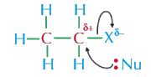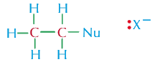

[[Link to topic 4-5]](#_Topic 4 - 5 / Organic Chemistry)

### Nucleophilic substitution reactions

Halogens are more EN than C. The C-X bond is polar: Cδ+-Xδ-

Nucleophilic reaction - Nucleophile’s negative end attracted to molecule → attack

Nucleophilic substitution - substitution def + attacking molecule is nucleophile

└ Reaction rate depends on strength of C-X bond

└ EN ↑attraction of Nu to haloalkane ↑

## Haloalkanes

Most mechanisms of haloalkanes reactions are nucleophilic substitution reactions. A tertiary haloalkane reacts faster

### Reflux w/ OH-

**With aqueous solution → Alcohols**

RX + OH- → ROH + X-

Hydrolysis: RX + H2O → ROH + HX (heat + catalyst)

**With ethanolic solution → Alkenes**

This is an elimination reaction. [[reaction graph]](#_Reactions)

Rx with unsymmetrical alcohols will have a mixture of products

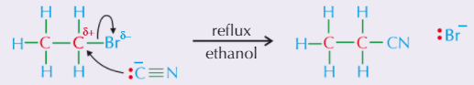RX + OH- → CnH2n + H2O + X-

### Reflux w/ CN- → Nitriles

RX + CN- → RCN + YX [Ethanolic solution]

RCN is called **alkane-nitrile**, where the alkane is the **original chain + 1**

### Heat in sealed tube w/ NH3 → Primary amines

The sealed tube is needed because NH3(g) will escape and can’t react

1. RX + NH3 → RNH3+ + X-
2. RNH3+X- + NH3 → RNH2 + NH4X - NH3 is used in excess
3. RX + 2NH3 → RNH2 + NH4X

RNH2 is called **alkan-amine**, where the alkane is the original chain

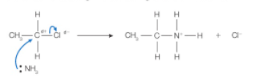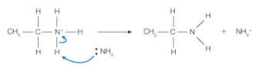

## IMG_256Alcohols

### Halogenation → Haloalkanes

**Reaction rate inversely proportional to bond enthalpy (EN diff) of H-X bond.** These are **nucleophilic substitution** reactions

Can use PCl5 to test for alcohols → form white fumes (HCl)

|  |  |  |
| --- | --- | --- |
| Chlorination | Bromination | Iodination |
| **1st 2nd** degree: PCl5  ROH + PCl5 → **RCl** + POCl3 + HCl(g)  **3rd** degree: conc. HCl  ROH + HCl → **RCl** + H2O | 1. KBr + H2SO4 → KHSO4 + HBr 2. ROH + HBr → **RBr** + H2O   Reagent: 50% conc. H2SO4 + KBr  Condition: **Reflux** | 1. 2P + 3I2 → 2PI3 2. 3ROH + Pl3 → 3RI + H3PO3   H3PO3 - phosphorous acid |

### Dehydration → Alkenes

Elimination reaction. Rx with unsymmetrical alcohols will have mixture of products [[reaction graph]](#_Reactions)

ROH → CnH2n + H2O - Heated with a conc. H2SO4 catalyst

### IMG_256Oxidation of 1° alcohols - Aldehydes → Carboxylic acids [[prefixes and stuff]](#_Topic 4 - 5 / Organic Chemistry)

[O]: **acidified Cr2O72-**

Aldehydes - [1°ROH] + [O] → CnH2n+1CHO + H2O - Distil product as it’s formed

Then carboxylic acids - CnH2n+1CHO + [O] → CnH2n+1COOH - Heat under reflux

At the same time - CnH2n+1OH + 2[O] → CnH2n+1COOH + H2O

### Oxidation of 2° alcohols - Ketones

Ketones - [2°ROH] + [O] → R1COR2+ H2O - Heat under reflux

3° alcohols don’t oxidize.

### Testing for aldehyde

**Fehling’s / Benedict’s**: Blue → **RED**

**acidified K2Cr2O7:** Red → **GREEN**

### **Testing for COOH**

Reacting with ROH + H2SO4 → Ester (Fruity smell)

### Reaction with Na

ROH + Na → RONa(s) + 1/2 H2(g)

RONa is Sodium alkoxide

## Common questions

|  |  |
| --- | --- |
| **Question** | **Answer** |
| Why is something in excess? | To allow full *x* reaction of *compound* |

### Practically obtaining oxidation products of ROH

|  |  |
| --- | --- |
| **Heating under reflux**    The products stay in the Rx mixture, since the vertical condenser sends them back to the heating flash  Water must always **enter at the bottom** of the condenser | **Distillation with addition**    Only the oxidizing agent is heated, the ROH is slowly added to the [O]. When the aldehyde forms, it immediately distills off and collected in the receiver, since they have a lower BP than the ROH |

## Purifying an organic liquid

### Fractionating column

The column is filled with glass pieces which acts as surfaces on which vapour leaving the column can condense.

This allows the vapour to undergo repeated distillation, providing a better separation

### Separation → Water soluble impurities

1. Add water to the product and shake well
2. The soluble and insoluble layers will be separated

If both are soluble in water, a organic solvent which the product is more soluble that is in water can be used

### IMG_256Distillation → Liquids with diff b.p.

The temperature on the thermometer will show the boiling point of the substance

### Recrystallisation → Organic solids

1. Dissolve solid in hot solvent to make saturated solution
2. Leave the solution to cool down slowly → Forming crystals of the product
3. Remove soluble impurities by filtering
4. Wash and dry the crystals

## Testing for purity

Melting range - range of temperatures from solid begins to melt → melts completely

Pure substances have a **specific m/b.p.** Using m.p. apparatus, the m.p. and melting range can be measured & compared with accurate values.

Impurities → m.p. ↓melting range ↑

## Mass spectrometry of organic compounds

[[Link to topic 2]](#_Mass spectrometry)

### Molecular ion peak

The peaks of the original molecular ion, including their isotopes.

Example: C2H4Cl2 w/ 1H 12C 35Cl 37Cl has 3 molecular ion peaks, as for C2H4Cl2 there are 3 isotopes - 55, 57, 77

### Fragmentation in hydrocarbons

The molecular ion’s breaking of C-C bonds to form smaller pieces

General formula: (C-C)+· → C· + C+

Longer chains: (C-C-C)+ → C· +(C-C)+

Other bonds can also be broken!

## Infrared spectroscopy

Just look at the wave number data and deduce what bond and function group are there, it isn’t that hard.

You can’t distinguish between isomers because the spectra doesn’t provide you with the corresponding data.

# References

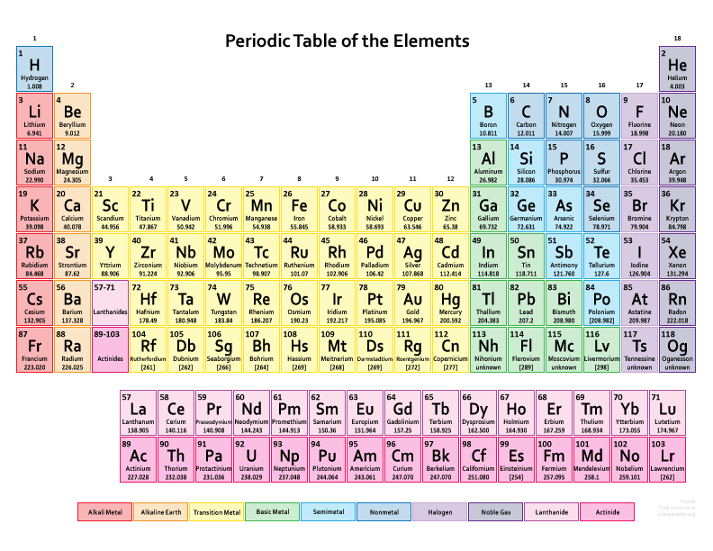⬋Atomic radius

⬈Ionisation energy

⬈Electronegativity

**Reactivity**

How easily atoms can lose / gain electrons & so react with other atoms

## Common ions

|  |  |  |  |
| --- | --- | --- | --- |
| **Common -ium -ide** | | **Uncommon ions -ate** | |
| NH4+ | Ammonium | CO32- | Carbonate [3] |
| H3O+ | Hydronium | HCO3- | Hydrogen carbonate [3] |
| OH- | Hydroxide |  |  |
| CN- | Cyanide |  |  |
| OCN- | Cyanate |  |  |
| O22- | Peroxide |  |  |
| **Common -ite[pt]** | |  | |
| NO2- | Nitrite |  |  |
| ClO2- | Chlorite (Hypo, ite, ate, per) | MnO4- | Permanganate |
| BrO2- | Bromite | C2H3O2- | Acetate |
| IO2- | Iodite | C2O42- | Oxalate |
| SO32- | Sulfite | CrO42- | Chromate |
| PO33- | Phosphite | C2O72- | Dichromate |

## Solubility chart

|  |  |  |  |  |  |
| --- | --- | --- | --- | --- | --- |
| **Soluble** | | | | | **Exceptions** |
| Nitrate | ClO4- | Potassium | Sodium | Ammonium | - |
| Chlorine | Iodine |  |  |  | Pb2+ Hg22+ Ag+ (PHAg) |
| Sulphate |  |  |  |  | Pb2+ Hg22+ Ag+ Ca2+ Ba2+ Sr2+ (Castro bear) |
| **Insoluble** | | | | |  |
| Carbonate | Phosphate |  |  |  | Group 1, NH4+ |
| Hydroxide |  |  |  |  | Group 1, NH4+ Ca2+ Ba2+ Sr2+ (Castro bear) |